Count Of Valleys And Mountains

Question

1. You are given a number n, representing the number of upstrokes / and number of downstrokes .  
2. You are required to find the number of valleys and mountains you can create using strokes.  
E.g.  
  
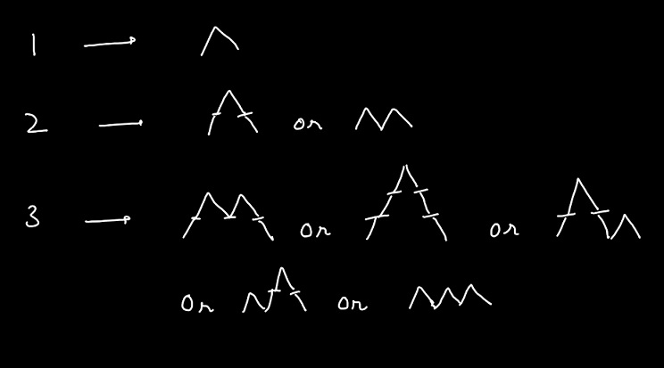  
  
Note -> At no point should we go below the sea-level. (number of downstrokes should never be more than number of upstrokes).

Input Format

A number n

Output Format

A number representing the number of valleys and mountains you can create using strokes.

Constraints

0 <= n <= 15

Sample Input

4

Sample Output

14